Project Report and Documentation for Vocxi Health Database

Document Title | Project Report and Documentation for Vocxi Health Database
Product Name | Vocxi Health Database
Primary Author | Hannah Burg
Contributing Team Members | Raj Vaibhav Gude
Document Date | 09-12-2025

Executive Summary
This document summarizes the project of the database for Vocxi Health, to manage inventory and collaborate with external contractors and the future production of the company.

Background
The company has experienced steady growth in the production and distribution of its devices. As production capacity expanded, the need for a reliable system to track devices throughout their lifecycle became increasingly critical. Previously, tracking was done through scattered records and manual processes, which made it difficult to quickly identify where a device was, what stage it was in, and whether it had reached its intended destination.
This lack of visibility created challenges in managing inventory, monitoring production efficiency, and ensuring timely delivery. Without a centralized system, it was also difficult to generate accurate reports or anticipate potential bottlenecks.
To address these challenges, the company initiated the development of a dedicated database solution. This database is designed to consolidate tracking information in one place, provide real-time status updates, and improve oversight of the entire production and distribution process.
In the future, this system will not only streamline operations but also serve as a foundation for advanced analytics and forecasting. By making data readily accessible and reliable, it will support decision-making and help the company adapt as it continues to grow.

Objective
The goal of this project is to develop a centralized SQL database to store and manage all data processed by the organization. The database will serve as the foundation for data access, reporting, analytics, and future automation initiatives.

- Centralize Information: Consolidate all device records into a single database for consistent and accessible tracking.
- Improve Traceability: Enable clear visibility of each device’s status, location, and movement throughout its lifecycle.
- Enhance Reporting: Provide accurate and timely data that can be used for operational monitoring, auditing, and decision-making.
- Increase Efficiency: Reduce reliance on manual processes and minimize errors caused by scattered or duplicate records.
- Support Scalability: Build a system that can grow with the company’s production capacity and integrate with future tools and technologies.
- Enable Future Analytics: Lay the groundwork for advanced reporting, forecasting, and business intelligence.

Table of Contents
This project is structured into the following subsections. Each subsection describes how data is generated, uploaded, and analyzed within the database system.
1. Summary
Provides an overview of the project, including goals, high-level workflows, and data sources.
- Data Source: Imported via .csv files.
- Examples: New builds for MBP devices, test datasets from contractors.
2. Inventory
Covers data related to equipment, materials, or digital resources used in the project.
- Data Generation: Internal records, vendor reports.
- Upload Method: .csv files ingested into the PostgreSQL backend.
- Analysis: SQL queries to track availability, usage, and lifecycle.
3. Manufacturing
Tracks build processes, production runs, and device assembly/testing data.
- Data Generation: Automated system logs, contractor testing outputs.
- Upload Method. Data will be uploaded to the backend of the database through .csv files. With can range from a new build for MBP devices to testing data with external contractors such as Intricon.
- Analysis: Performance trends, defect rates, and process validation.
4. Tracking
Monitors the flow of materials, test results, and device deployments.
- Data Generation: Transaction logs, shipment details, project activity updates.
- Upload Method: .csv uploads and Retool-based forms.
- Analysis: Traceability reports, compliance metrics, and audit trails.

Documentation

Materials/ Traceability or Source Documents

Set-up Configuration
Provide equipment settings/ set-up as relevant.
The required settings for managing this
This project leverages a combination of Retool, PostgreSQL, VS Code (or another editor), and Microsoft Azure for infrastructure and resource management. Below are the tools and their roles in the workflow:
Retool: The software Retool was used to produce the front-end application to the database. Retool is a low-code platform designed for building custom internal tools. It allows developers to create user interfaces for their specific needs and connect directly to a backend database as needed.
PostgreSQL: Primary database for storing and querying project data.
VS Code (or equivalent editor): Development environment for managing scripts, queries, and integrations.
Microsoft Azure: Provides hosting infrastructure, resource scaling, and cost management.
All software should be installed and configured on the development machine with the credentials provided by the project admin.

Key Components
- Database Schema and Dictionary
  - Table names and functions
    - Inventory:
      - Inventory_Master main table of inventory. It contains all data about each pcb_id that has been manufactured, tested, its testing history, etc.
      - Inventory_Main: Main view of inventory, displayed through the front-end UI, with the ability to filter certain data sets
      - Inventory_Log: historical log of changes made, specifically by who, when the change was made, what rows were affected the status of a specific pcb_id (board_status)
    - Manufacturing
      - Intricon_log- csv input data from Intricon, our external contractor.
      - Manufacturing_csv_uploads – historical log of the specific file_name, changes made, specifically by who, when the change was made, what rows were affected the status
      - Device_rebuild – Data when pcb_id is returned from the field, where is it processed (cleaned, backed, tested, reprocessed)
      - Device_build – Data of pcb_id when it is first sent to Vocxi, where is it tested to ensure it passes all
    - Tracking
    - Summary: Table of all summarized data, filtered by use_allocation, accepted pcb_ids by state, and wafer_id information
  - Field names and data types
    - Inventory
      - Inventory_Master
      - Inventory_main
      - Inventory_log
    - Manufacturing
      - Intricon_Log
        - _id
        - Start_time
        - End_time
        - Test_version
        - Breathe_test_result_mfg
        - Board_level_test_result
        - Board_level_failure_reason
        - Pcb_id
        - Device_id
        - Manuf_date
        - Fw_ver
        - Protocol_ver
        - Python_version
        - Computer_domain_username
        - Operator name
        - Lot_number
        - Encryption_key
        - Resue_counter
        - Asy_sn
        - Board_id_mobile
        - Uploaded_date_time
      - Manufacturing_csv_uploads
        - Id
        - File_name
        - Uploaded_At
        - Uploaded_by
        - Version
        - Rows_Affected
        - Uploaded_status

    - Tracking
    - Summary
      - Wafer id
      - No_built
      - No_rework
      - No_scrap
      - No_accepted
      - Pt_accepted
      - Use_allocation
  - Keys (primary and foreign)
  - Constraints (e.g., NOT NULL, UNIQUE)
  - Indexes for performance optimization
  - Examples to illustrate how the schema is used

- Data Dictionary
  - Table and column descriptions
    - Inventory:
      - Inventory_Master main table of inventory. It contains all data about each pcb_id that has been manufactured, tested, its testing history, etc.
      - Inventory_Main: Main view of inventory, displayed through the front-end UI, with the ability to filter certain data sets
      - Inventory_Log: historical log of changes made, specifically by who, when the change was made, what rows were affected the status of a specific pcb_id (board_status)
    - Manufacturing
      - Intricon_log- csv input data from Intricon, our external contractor.
      - Manufacturing_csv_uploads – historical log of the specific file_name, changes made, specifically by who, when the change was made, what rows were affected the status
      - Device_rebuild – Data when pcb_id is returned from the field, where is it processed (cleaned, backed, tested, reprocessed)
      - Device_build – Data of pcb_id when it is first sent to Vocxi, where is it tested to ensure it passes all
    - Tracking
    - Summary
      - Wafer id – Column for each wafer that is manufactured and entered in the system
      - No_built: no pcb_id that has been manufactured based on specific wafer_id
      - No_rework: no. pcb_id that has been tested and returned to manufacturer for rework
      - No_scrap: no. pcb_id that has been tested, reworked by manufacturer, and returned to Vocxi for testing and flagged as “scrap”, which is no longer able to be used
      - No_accepted: pcb_id accruing no. after it has been tested and deemed able to be used after analysis
      - Pt_accepted: percentage of pcb_id per wafer that has been tested and marked as acceptable
      - Use_allocation: summary of no. of pcb_id’s that have a specific use allocation
  - Field names and data types
    - Inventory
      - Inventory_Master
      - Inventory_main
      - Inventory_log
    - Manufacturing
      - Intricon_Log
        - _id
        - Start_time
        - End_time
        - Test_version
        - Breathe_test_result_mfg
        - Board_level_test_result
        - Board_level_failure_reason
        - Pcb_id
        - Device_id
        - Manuf_date
        - Fw_ver
        - Protocol_ver
        - Python_version
        - Computer_domain_username
        - Operator name
        - Lot_number
        - Encryption_key
        - Resue_counter
        - Asy_sn
        - Board_id_mobile
        - Uploaded_date_time
      - Manufacturing_csv_uploads
        - Id
        - File_name
        - Uploaded_At
        - Uploaded_by
        - Version
        - Rows_Affected
        - Uploaded_status

    - Tracking
    - Summary
      - Wafer id
      - No_built
      - No_rework
      - No_scrap
      - No_accepted
      - Pt_accepted
      - Use_allocation

  - Data types and formatting rules
  - Default values and allowed ranges
  - Nullability and constraints
  - Business definitions and usage examples

- Entity-Relationship Diagram (ERDs)
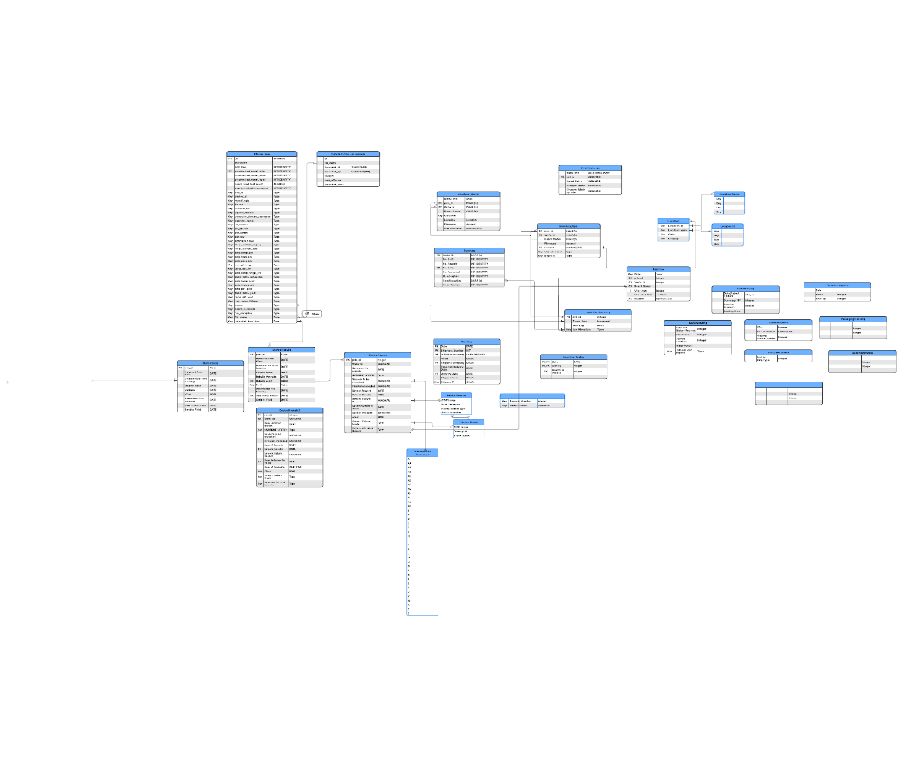

- SQL Scripts and Procedures
  - Naming conventions and versioning
  - Purpose of each stored procedure
    - SPROC1: loads .csv file from user input and loads that file into the backend using a JavaScript query and the stored procedure to insert it into the intricon_data and manufacturing_csv_uploads
    - SPROC2
    - SPROC3
  - Input/output parameters
  - Sample calls and expected results
  - Notes on dependencies or cross-database functions

- User Guides and Developer Notes
  - Steps to access the database securely
  - How to execute commonly used queries
  - Guidelines for data entry or modification
  - Known issues and workarounds
  - Best practice and troubleshooting tips

Results

Provide evidence to support the study objective and conclusion. Explain data using tables, graphs, and/or mathematical calculations, as appropriate.

Conclusion
Provide confirmation that the study objective has or has not been met. Explain what was learned during analysis and provide an overall conclusion.

Reference Documents
Entity Relationship Diagram

Wireframes in PPT

The image below describes the tables and relationships between each data set

